Algorithms and Programming I
LAB 7

Exercises

1- Write a program that prints a given sparse matrix as a regular full matrix.

Don’t use SetCursorPosition command.

Don’t take any input from the user, assign the sparse array in the program code.

Example:

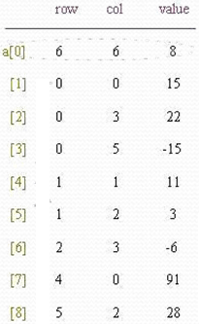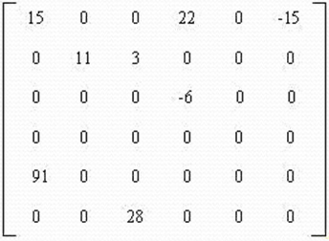

int[,] s = new int[,] {{6,6,8},{0,0,15},{0,3,22},{0,5,-15},{1,1,11},{1,2,3}, {2,3,-6}, {4,0,91}, {5,2,28}};

Output:
15 0 0 22 0 -15
0 11 3 0 0 0
0 0 0 -6 0 0
0 0 0 0 0 0
91 0 0 0 0 0
0 0 28 0 0 0

2- Write a program that prints the minimum element of a given sparse matrix.

Don’t take any input from the user, assign the sparse array in the program code.

Example:
int[,] s = new int[,] {{6,6,8}, {0,0,15}, {0,3,22}, {0,5,-15},
{1,1,11}, {1,2,3}, {2,3,-6}, {4,0,19}, {5,2,12}};
Output: -15

3- Write a program that finds a given sparse matrix is a skew-symmetric matrix or not. The program should print true or false.
Don’t take any input from the user, assign the sparse array in the program code.

A skew-symmetric matrix is a square matrix A whose transpose is also its negative; that is, it satisfies the equation A = −A^{T}. If the entry in the i ^{th} row and j ^{th} column is a_{ij}, i.e. A = (a_{ij}) then the symmetric condition becomes a_{ij} = −a_{ji}.

Examples:
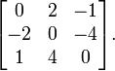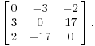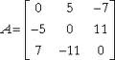

int[,] s = new int[,] {{3,3,6}, {0,1,2}, {0,2,-1}, {1,0,-2},
{1,2,-4}, {2,0,1}, {2,1,4}};
Output: true

4- Write a program that finds a given sparse matrix is a upper triangular matrix or not. The program should print true or false.

A square matrix is called upper triangular if all the entries below the main diagonal are zero.

Don’t take any input from the user, assign the sparse array in the program code.

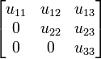

Examples:
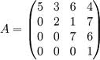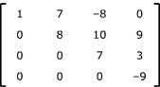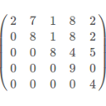

int[,] s = new int[,] {{3,3,6},{0,0,2},{0,1,5},{0,2,6},{1,1,4},{1,2,9},{2,2,8}};
Output: true

Questions

Upload the answers of the following questions from http://lectures.cs.deu.edu.tr/ web site until November 27, 23:55.

1- Write a program that finds a given sparse matrix is a signature matrix or not. The program should print true or false.

Don’t take any input from the user, assign the sparse array in the program code.

A signature matrix is a diagonal matrix whose diagonal elements are plus or minus 1.

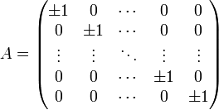

Examples:
int[,] s = new int[,] {{6,6,6}, {0,0,1}, {1,1,-1}, {2,2,1}, {3,3,-1}, {4,4,1}, {5,5,1}};
Output: true

int[,] s = new int[,] {{6,6,6}, {0,0,1}, {1,1,-1}, {2,2,5}, {3,3,-1}, {4,5,1}, {5,5,1}};
Output: false

int[,] s = new int[,] {{6,6,6}, {0,0,1}, {1,1,-1}, {2,3,1}, {3,3,-1}, {4,5,1}, {5,5,1}};
Output: false

2- Write a program that takes two numbers x and y from the user and exchanges x^{th} column and y^{th} column of the sparse matrix.

Don’t take any input from the user, assign the sparse array in the program code.

Example:
Input: 2 6
int[,] s = new int[,] {{6,6,8},{0,0,15},{0,3,22},{0,5,-15},{1,1,11},{1,2,3},{2,3,-6}, {4,0,91}, {5,2,28}};

15 0 0 22 0 -15
0 11 3 0 0 0
0 0 0 -6 0 0
0 0 0 0 0 0
91 0 0 0 0 0
0 0 28 0 0 0

Output:
s = {{6,6,8},{0,0,15},{0,1,-15},{0,3,22},{1,2,3},{1,5,11},{2,3,-6},{4,0,91},{5,2,28}};

15 -15 0 22 0 0
0 0 3 0 0 11
0 0 0 -6 0 0
0 0 0 0 0 0
91 0 0 0 0 0
0 0 28 0 0 0

